November 19th, 2024 (October - January 2025)
Aiden Vance

This project has been a work in progress for the past couple months. I started working on it in november last year, after I had exhausted all of my units for computer science. I spent the first few weeks just figuring out what to even do, what step to take. This proved more difficult than I had imagined, as there are just so many cool things you can do with python. From web design to video games to facial recognition, text based games, chat bots, password generators, and so much more, the bounds are endless. I eventually settled on turtle, however. Not the animal, but the built-in module python has for drawing things to the screen. I was interested in creating generative art. You give the computer some basic guidelines, rules, then it uses these to create an artwork. These artworks typically have a certain level of randomness built in, so that the piece of art generated is different every time. I spent my first couple days working with Turtle, just messing around and trying to figure out how it all worked. After I created some crude fractal-like generations, however, I realized that I really was interested in something else, fractals! There are so many different fractals, all originating from simple yet different rules. Turtle is perfect for generating fractals, as it is extremely easy to use. You can use python to compute the rules for generation, and turtle to draw it to the screen.

Each fractal generated relies on something called an L-system. An L-system is essentially a set of characters and rules that go along with them to create recursive patterns. Each L-system has an alphabet of letters used, constants, an axiom (starting letter) , the ruleset, and any other important information like the amount of “steps” to take or degrees to rotate, and also the interpretation of the character sequence generated. For example, below is the L-system for the Sierpinski Triangle:

Alphabet: “F”, “G”
Constants: “+”, “-”
Axiom: “F”
Rules: (F -> F-G+F+G-F), (G -> GG)
Angle: 120 degrees
Step: 8 (could be any number, depending on how big you want the fractal to generate on the screen)

This L-system would generate characters like so:

Iteration 0: F
Iteration 1: F-G+F+G-F
Iteration 2: F-G+F+G-F-GG+F-G+F+G-F+GG-F-G+F+G-F
F-G+F+G-F-GG+F-G+F+G-F+GG-F-G+F+G-F-GGGG+F-G+F+G-F-GG+F-G+F+G-F+GG-F-G+F+G-F+GGGG-F-G+F+G-F-GG+F-G+F+G-F+GG-F-G+F+G-F
Iteration 3: F-G+F+G-F-GG+F-G+F+G-F+GG-F-G+F+G-F-GGGG+F-G+F+G-F-GG+F-G+F+G-F+GG-F-G+F+G-F+GGGG-F-G+F+G-F-GG+F-G+F+G-F+GG-F-G+F+G-F-GGGGGGGG+F-G+F+G-F-GG+F-G+F+G-F+GG-F-G+F+G-F-GGGG+F-G+F+G-F-GG+F-G+F+G-F+GG-F-G+F+G-F+GGGG-F-G+F+G-F-GG+F-G+F+G-F+GG-F-G+F+G-F+GGGGGGGG-F-G+F+G-F-GG+F-G+F+G-F+GG-F-G+F+G-F-GGGG+F-G+F+G-F-GG+F-G+F+G-F+GG-F-G+F+G-F+GGGG-F-G+F+G-F-GG+F-G+F+G-F+GG-F-G+F+G-F
Iteration 4: …

These strings of characters and constants are then passed to the interpretation section to be turned into movements that generate the fractal. Below is the interpretation for the sierpinski triangle, in word form:

“F”, “G” - draw a segment, length is determined by step
“+” - turn right by 120 degrees
“-” - turn left by 120 degrees

Now you can see that the proper rules and interpretation can create any fractal.

Honeycombs

The honeycomb “fractal” isn’t actually a fractal, but it does utilize an L-system to generate itself.

Alphabet: “A”, “B”
Constants: none
Axiom: “A”
Rules: (A -> AB), (B -> A)
Angle: 60 degrees
Step: 16 (could be any number, depending on how big you want the fractal to generate on the screen)

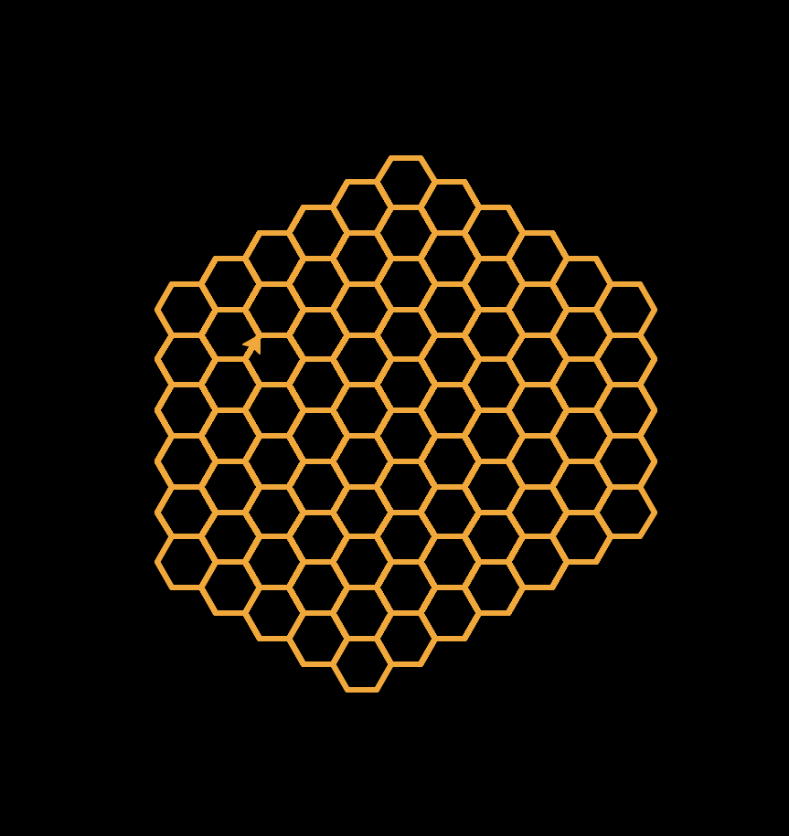
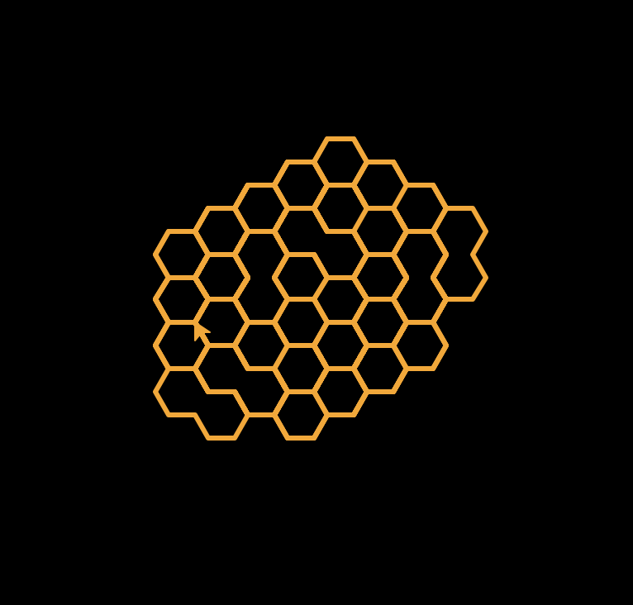
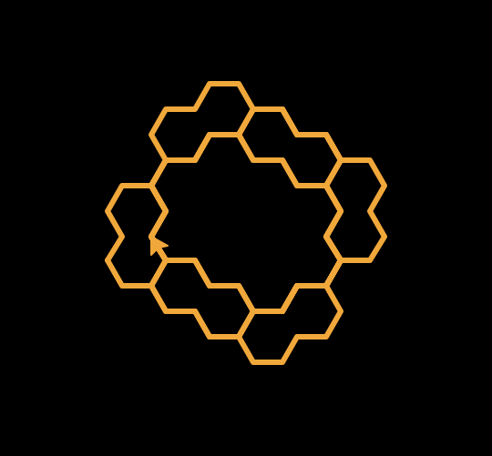

Iterations from left to right: 10, 15, 20

Sierpinski Triangle

Alphabet: “F”, “G”
Constants: “+”, “-”
Axiom: “F”
Rules: (F -> F-G+F+G-F), (G -> GG)
Angle: 120 degrees
Step: 8 (could be any number, depending on how big you want the fractal to generate on the screen)

Iterations from left to right: 5, 6, 7

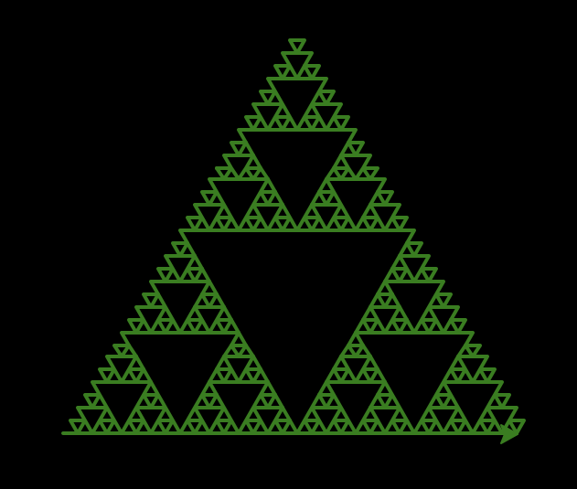
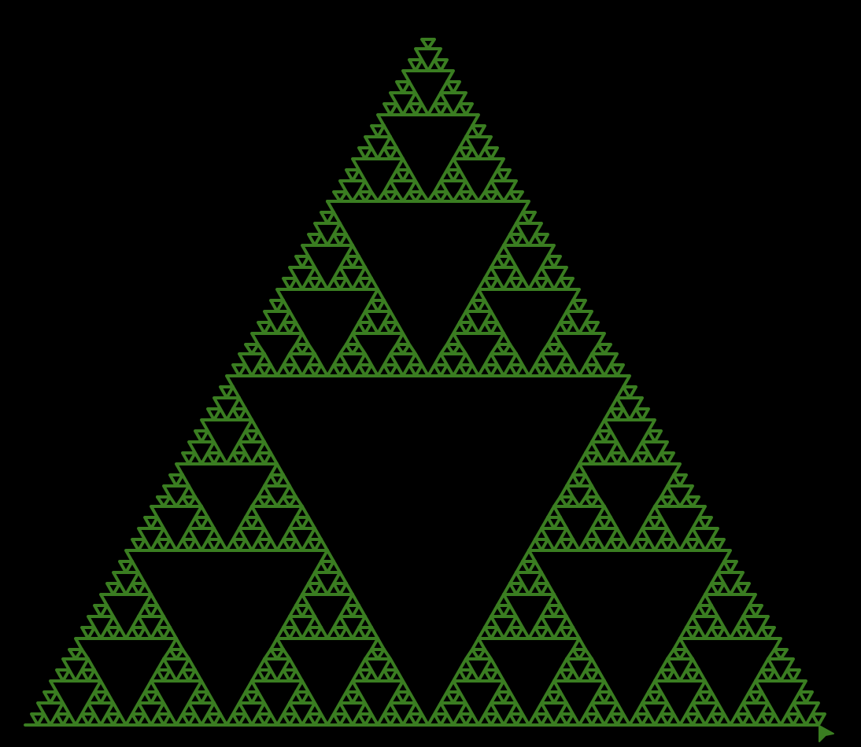
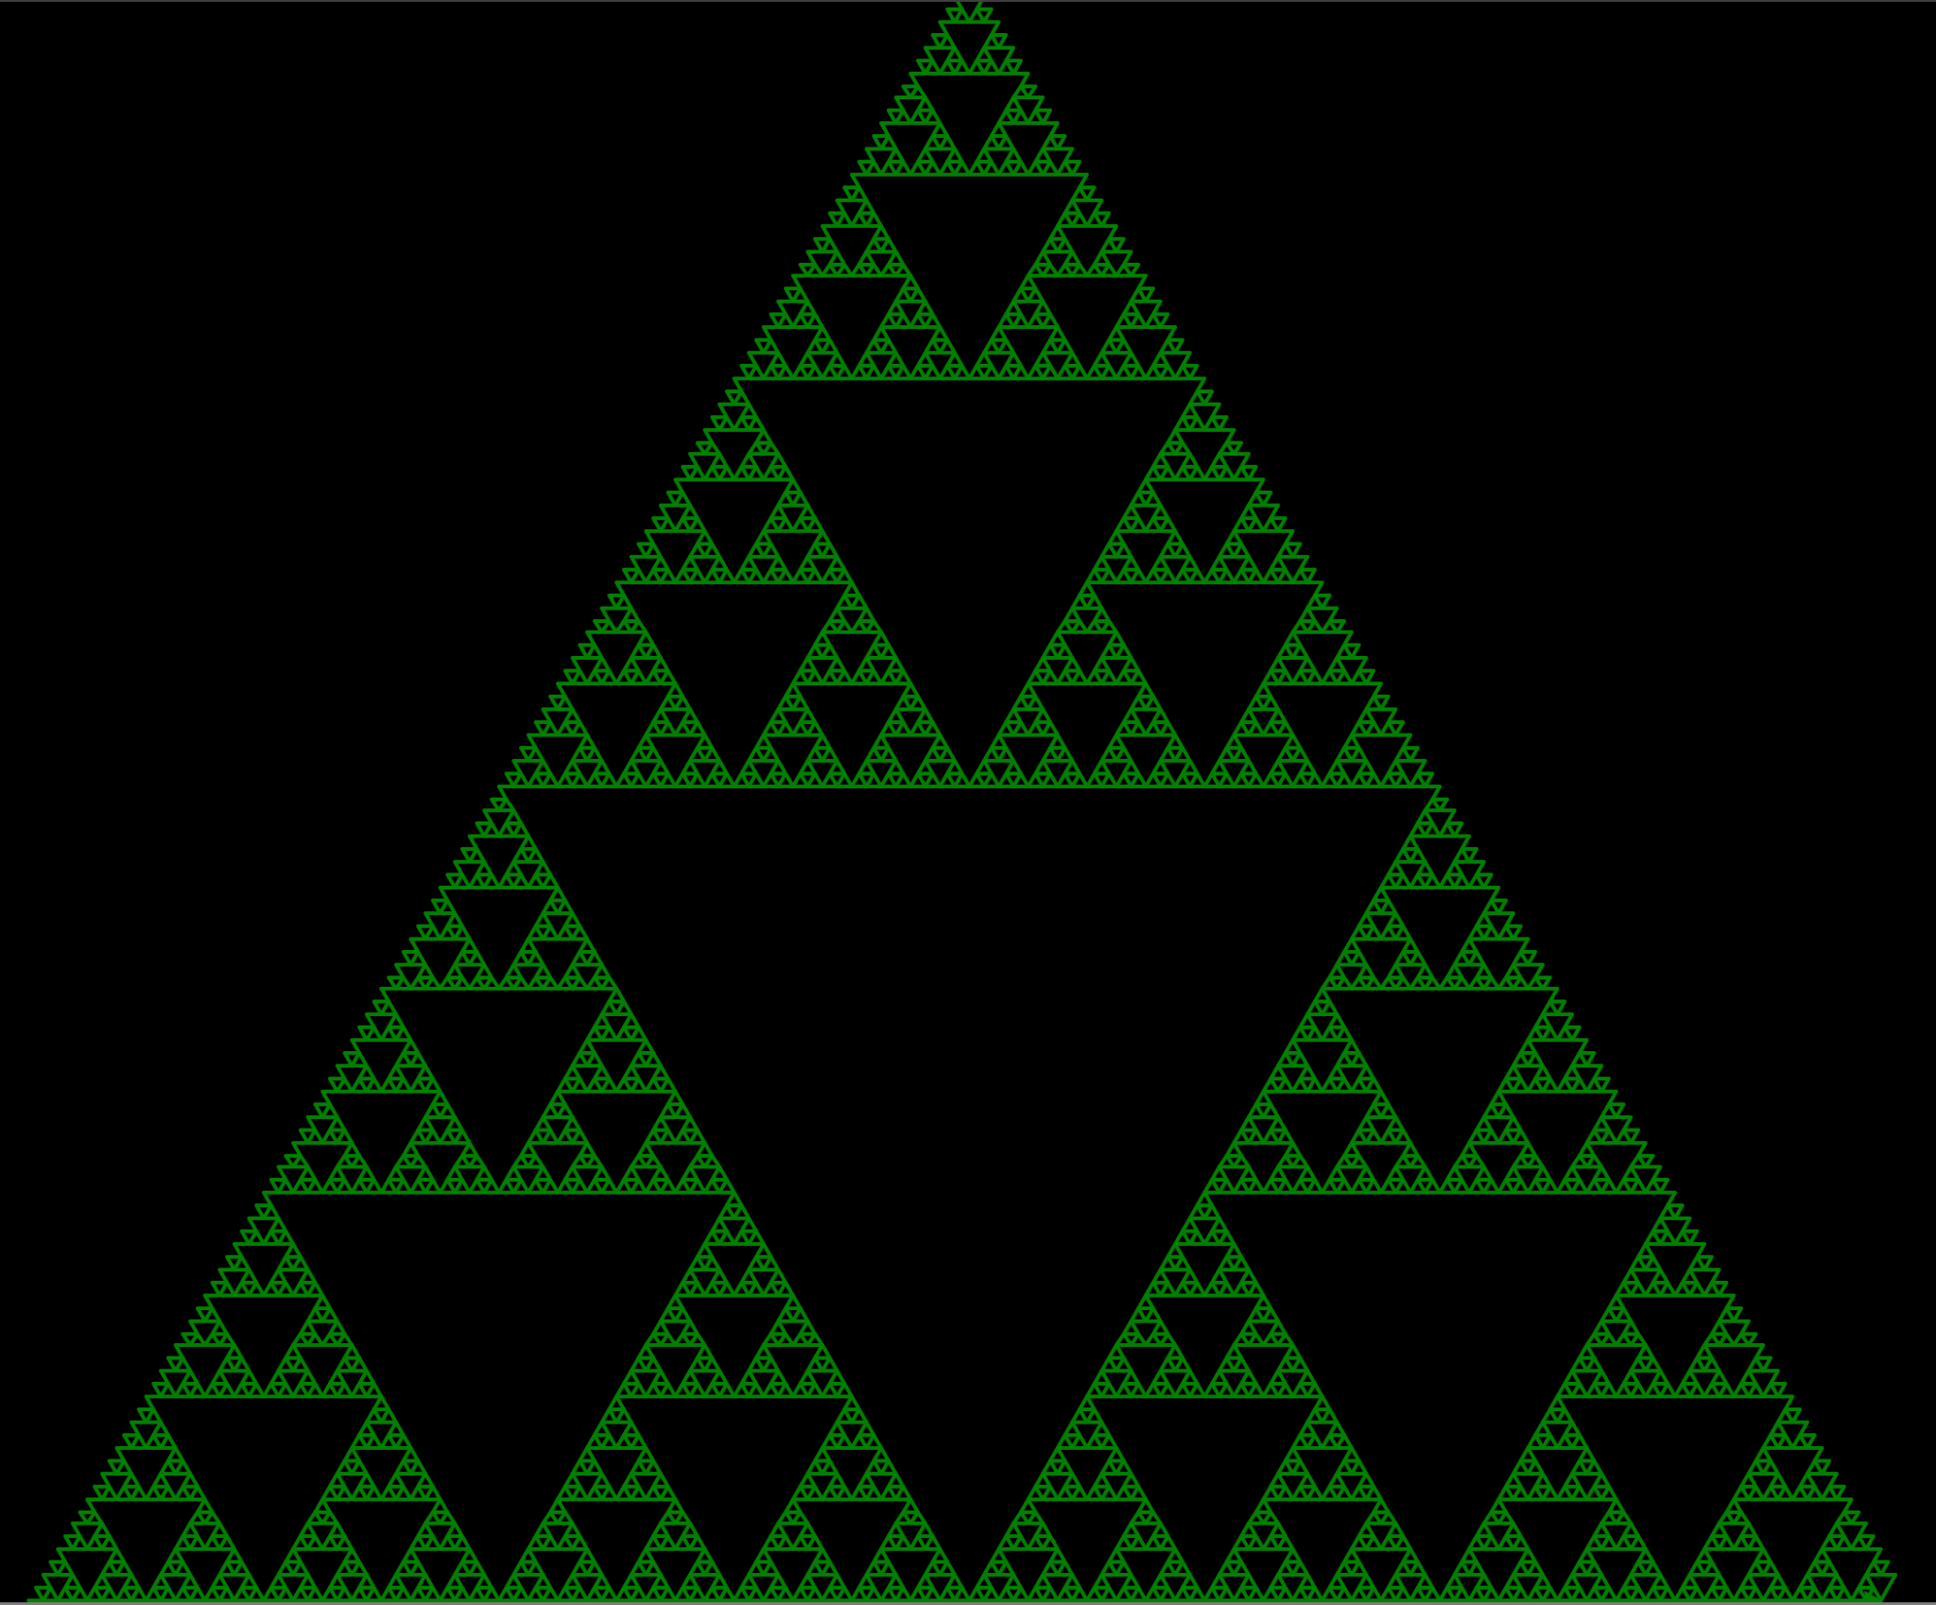

Harter-Heighway Dragon

Alphabet: “F”, “X”, “Y”
Constants: “+”, “-”
Axiom: “FX”
Rules: (X -> X+YF+), (Y -> -FX-Y)
Angle: 90 degrees
Step: 4 (could be any number, depending on how big you want the fractal to generate on the screen)
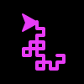
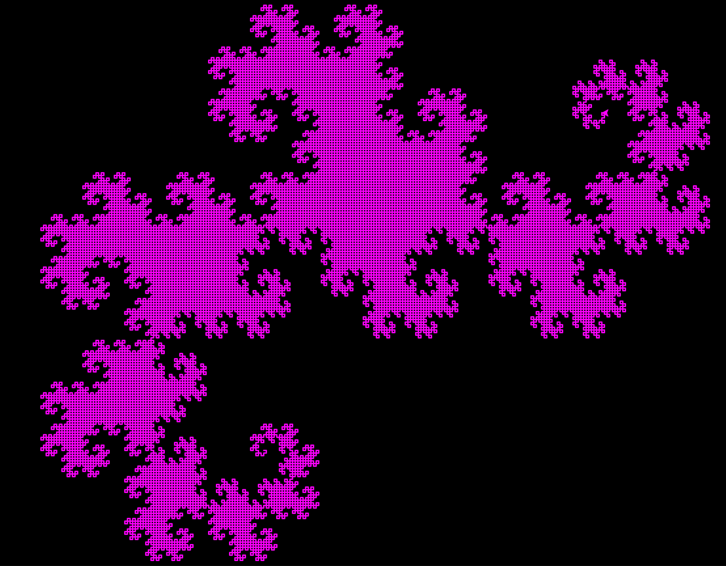
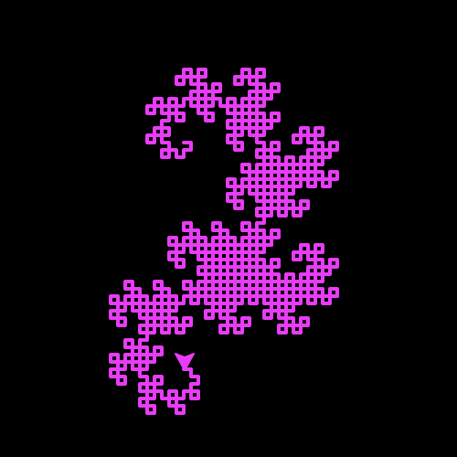
Iterations from left to right: 5, 10, 15

Sierpinski Carpet

Alphabet: “F”, “U”, “G”, “D”
Constants: “+”, “-”
Axiom: “F”
Rules: (F -> F+F-F-F-UGD+F+F+F-F), (G -> GGG)
Angle: 90 degrees
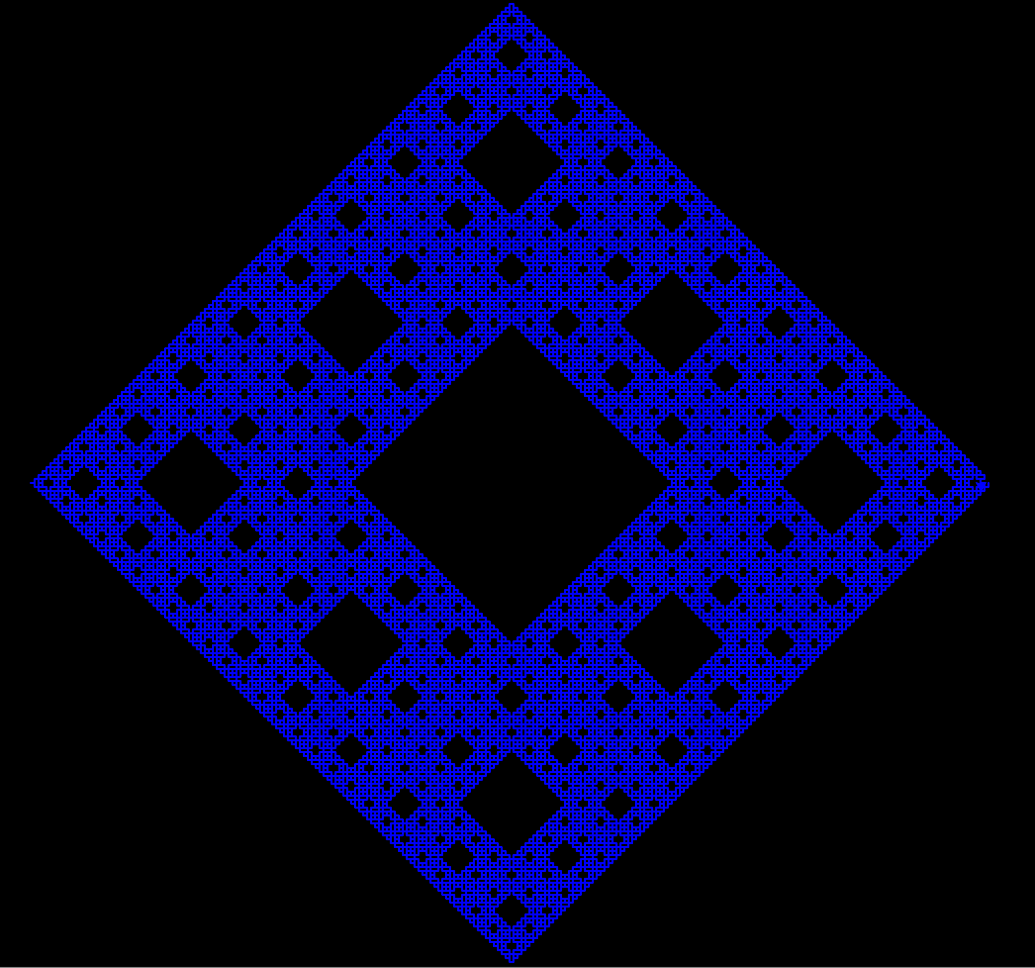
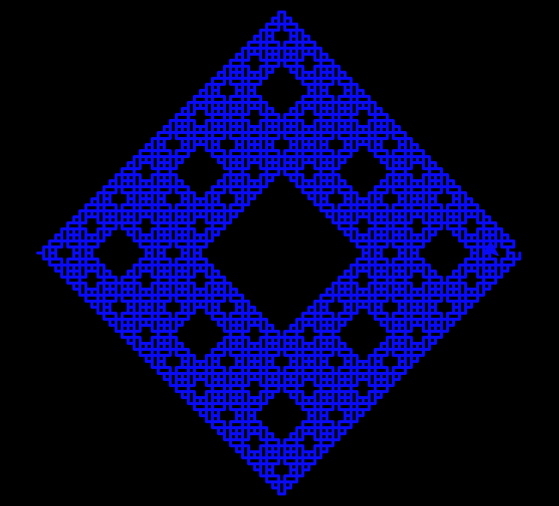
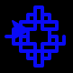
Step: 4 (could be any number, depending on how big you want the fractal to generate on the screen)
Iterations from left to right: 2, 4, 5

Levy Dragon

Alphabet: “F”
Constants: “+”, “-”
Axiom: “F”
Rules: (F -> +F--F+)
Angle: 45 degrees
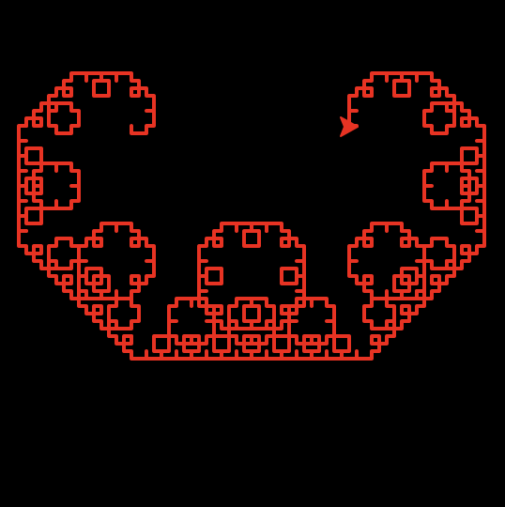

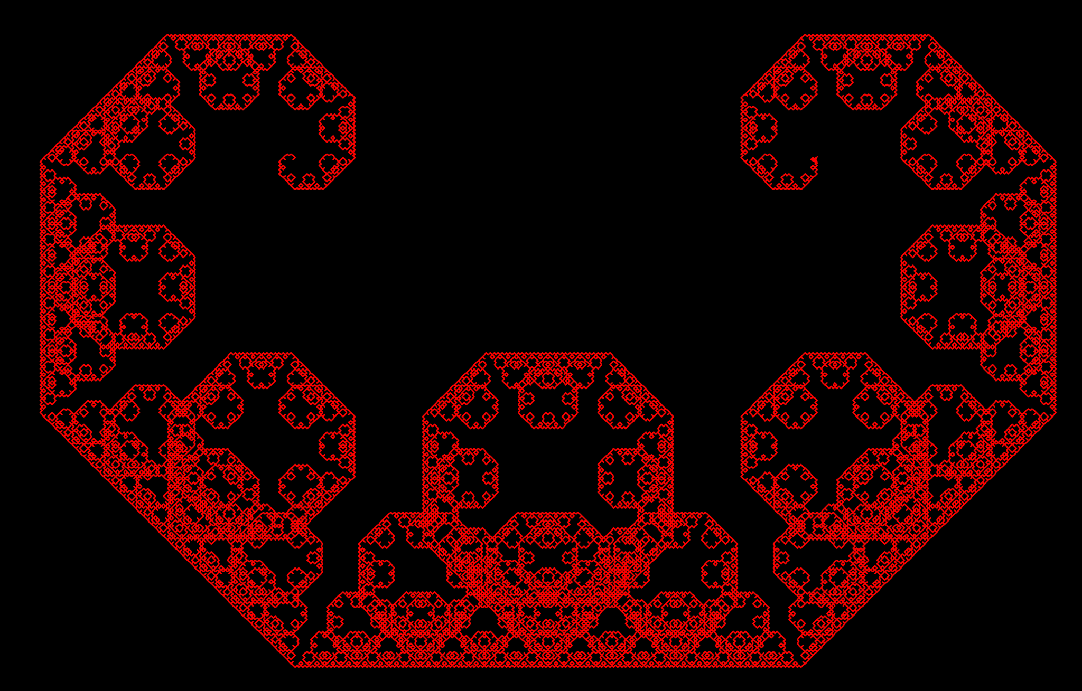
Step: 4 (could be any number, depending on how big you want the fractal to generate on the screen)
Iterations from left to right: 5, 10, 15

McWorter’s Pentigree

Alphabet: “F”
Constants: “+”, “-”
Axiom: “F”
Rules: (F -> +F++F----F--F++F++F-)
Angle: 36 degrees
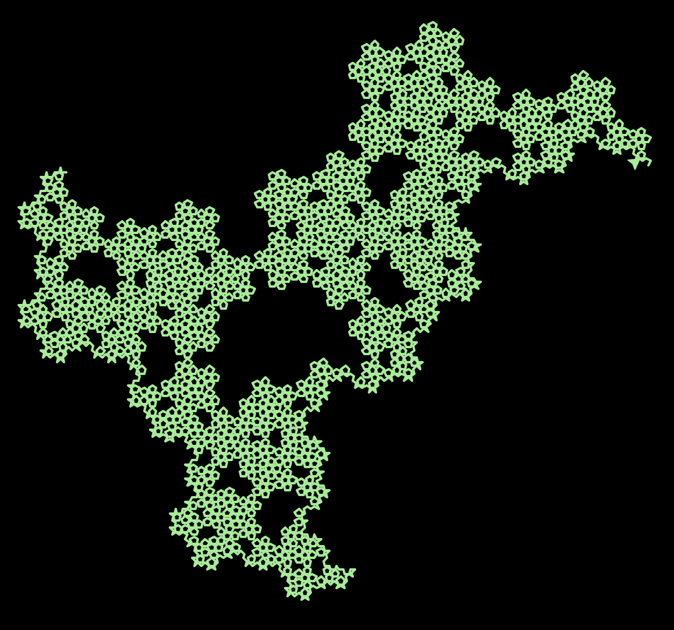
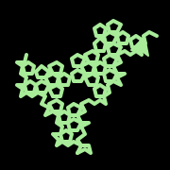
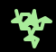
Step: 4 (could be any number, depending on how big you want the fractal to generate on the screen)
Iterations from left to right: 2, 3, 5

Koch Curve

Alphabet: “F”
Constants: “+”, “-”
Axiom: “FX”
Rules: (F -> F-F++F-F)
Angle: 60 degrees
Step: 4 (could be any number, depending on how big you want the fractal to generate on the screen)
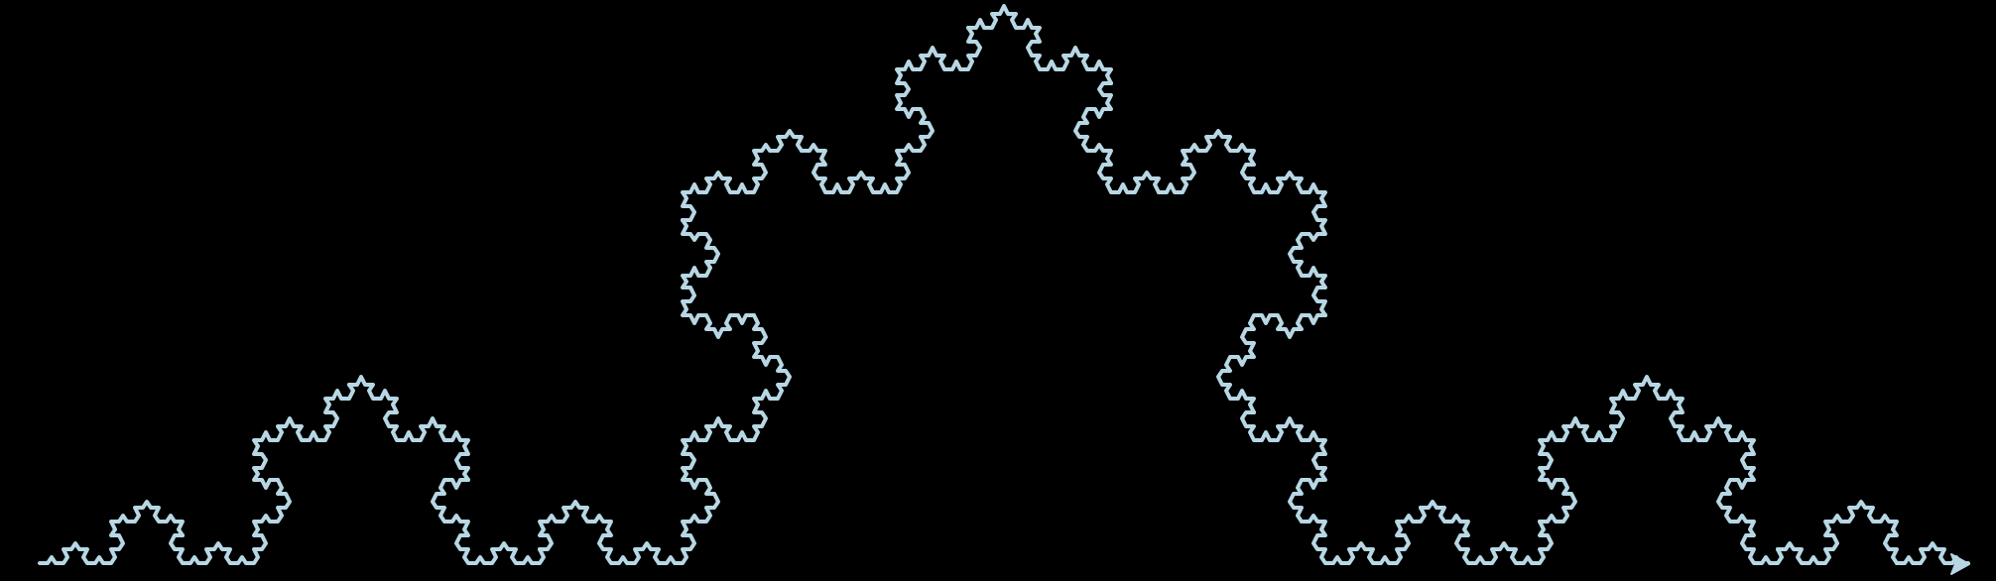
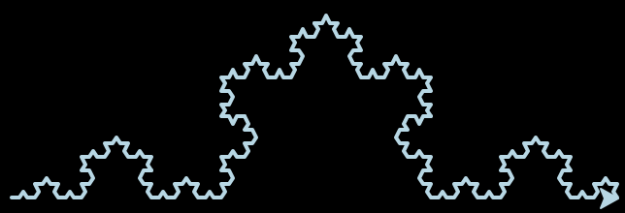
Iterations from left to right: 4, 5

Koch Snowflake (triangle variation)

Alphabet: “F”
Constants: “+”, “-”
Axiom: “F++F++F”
Rules: (F -> F-F++F-F)
Angle: 60 degrees
Step: 4 (could be any number, depending on how big you want the fractal to generate on the screen)
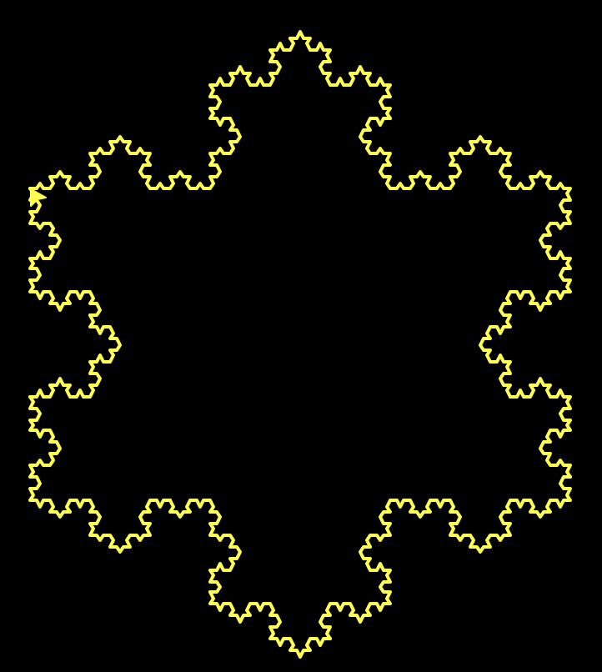
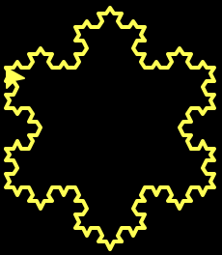
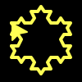
Iterations from left to right: 2, 3, 4

Koch Snowflake (hexagon variation)

Alphabet: “F”
Constants: “+”, “-”
Axiom: “F+F+F+F+F+F”
Rules: (F -> F-F++F-F)
Angle: 60 degrees
Step: 4 (could be any number, depending on how big you want the fractal to generate on the screen)
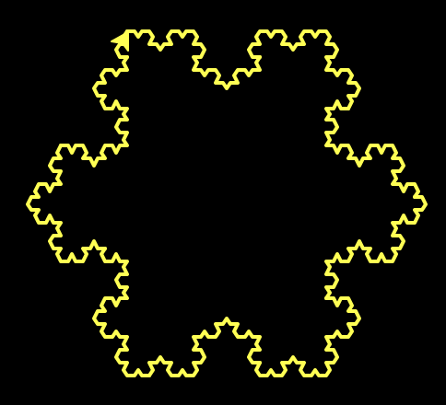
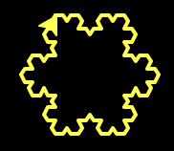
Iterations from left to right: 2, 3, 4

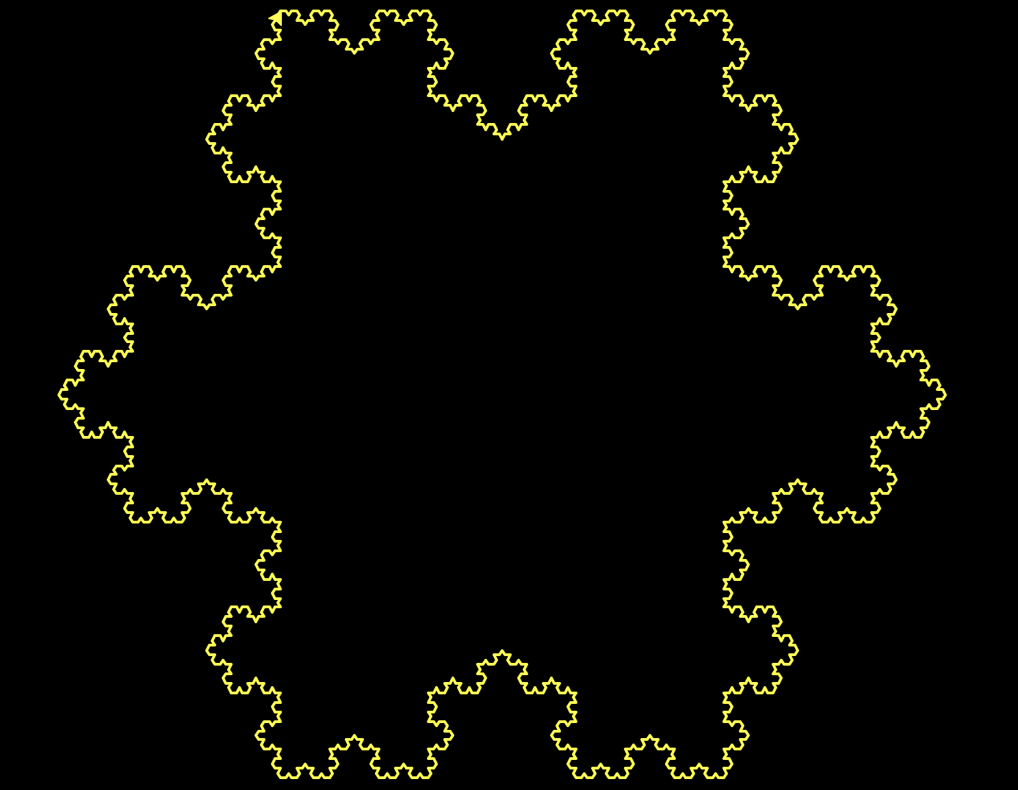

Pentadentrite

Alphabet: “F”
Constants: “+”, “-”
Axiom: “F”
Rules: (F -> F-F+F++F-F-F)
Angle: 72 degrees
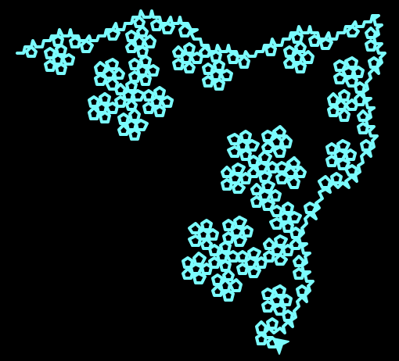
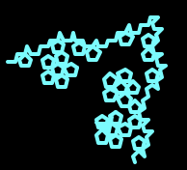
Step: 4 (could be any number, depending on how big you want the fractal to generate on the screen)
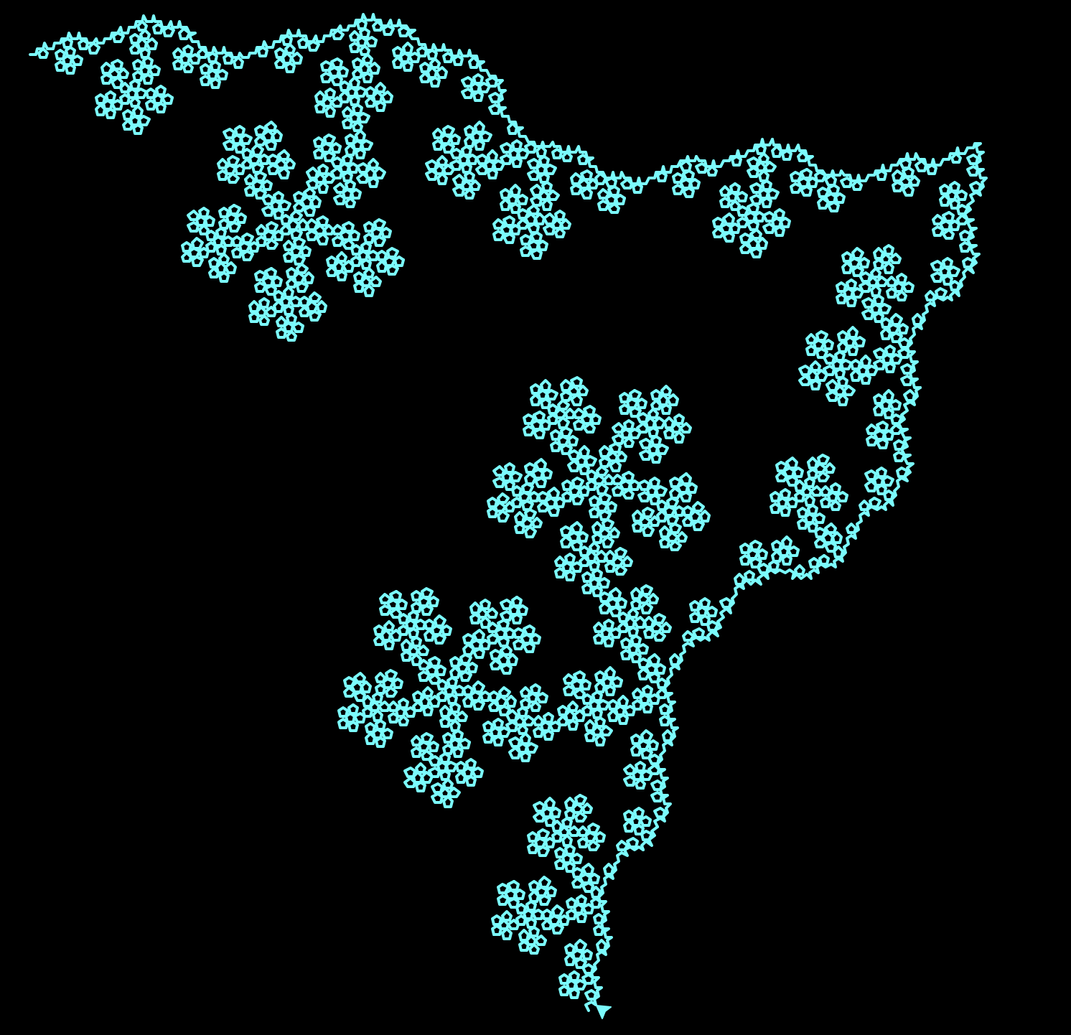
Iterations from left to right: 3, 4, 5

